- Volume 1 | Issue 1  Autumn 2022 | South Derbyshire Mining Preservation Group Newsletter
Welcome | Despite our loss of members (due to age and the pandemic), we are now up and running! You don’t need to be an ex-miner to join us – maybe you have an interest in history, helping, or just fancy a chat.  This is our brand-new newsletter. We also have a new website so please come and take a look – www.sdmpg.webador.co.uk. And if you are on twitter please follow us @S_D_M_P_G. We meet in person at Gresley Old Hall every Tuesday, 10-12pm. You can also contact us via email: southderbys.mpg@gmail.com.  We’d love to hear from you…  We need you!  We now need to complete the cataloguing and recording work started pre-pandemic. For this we would welcome assistance from volunteers.  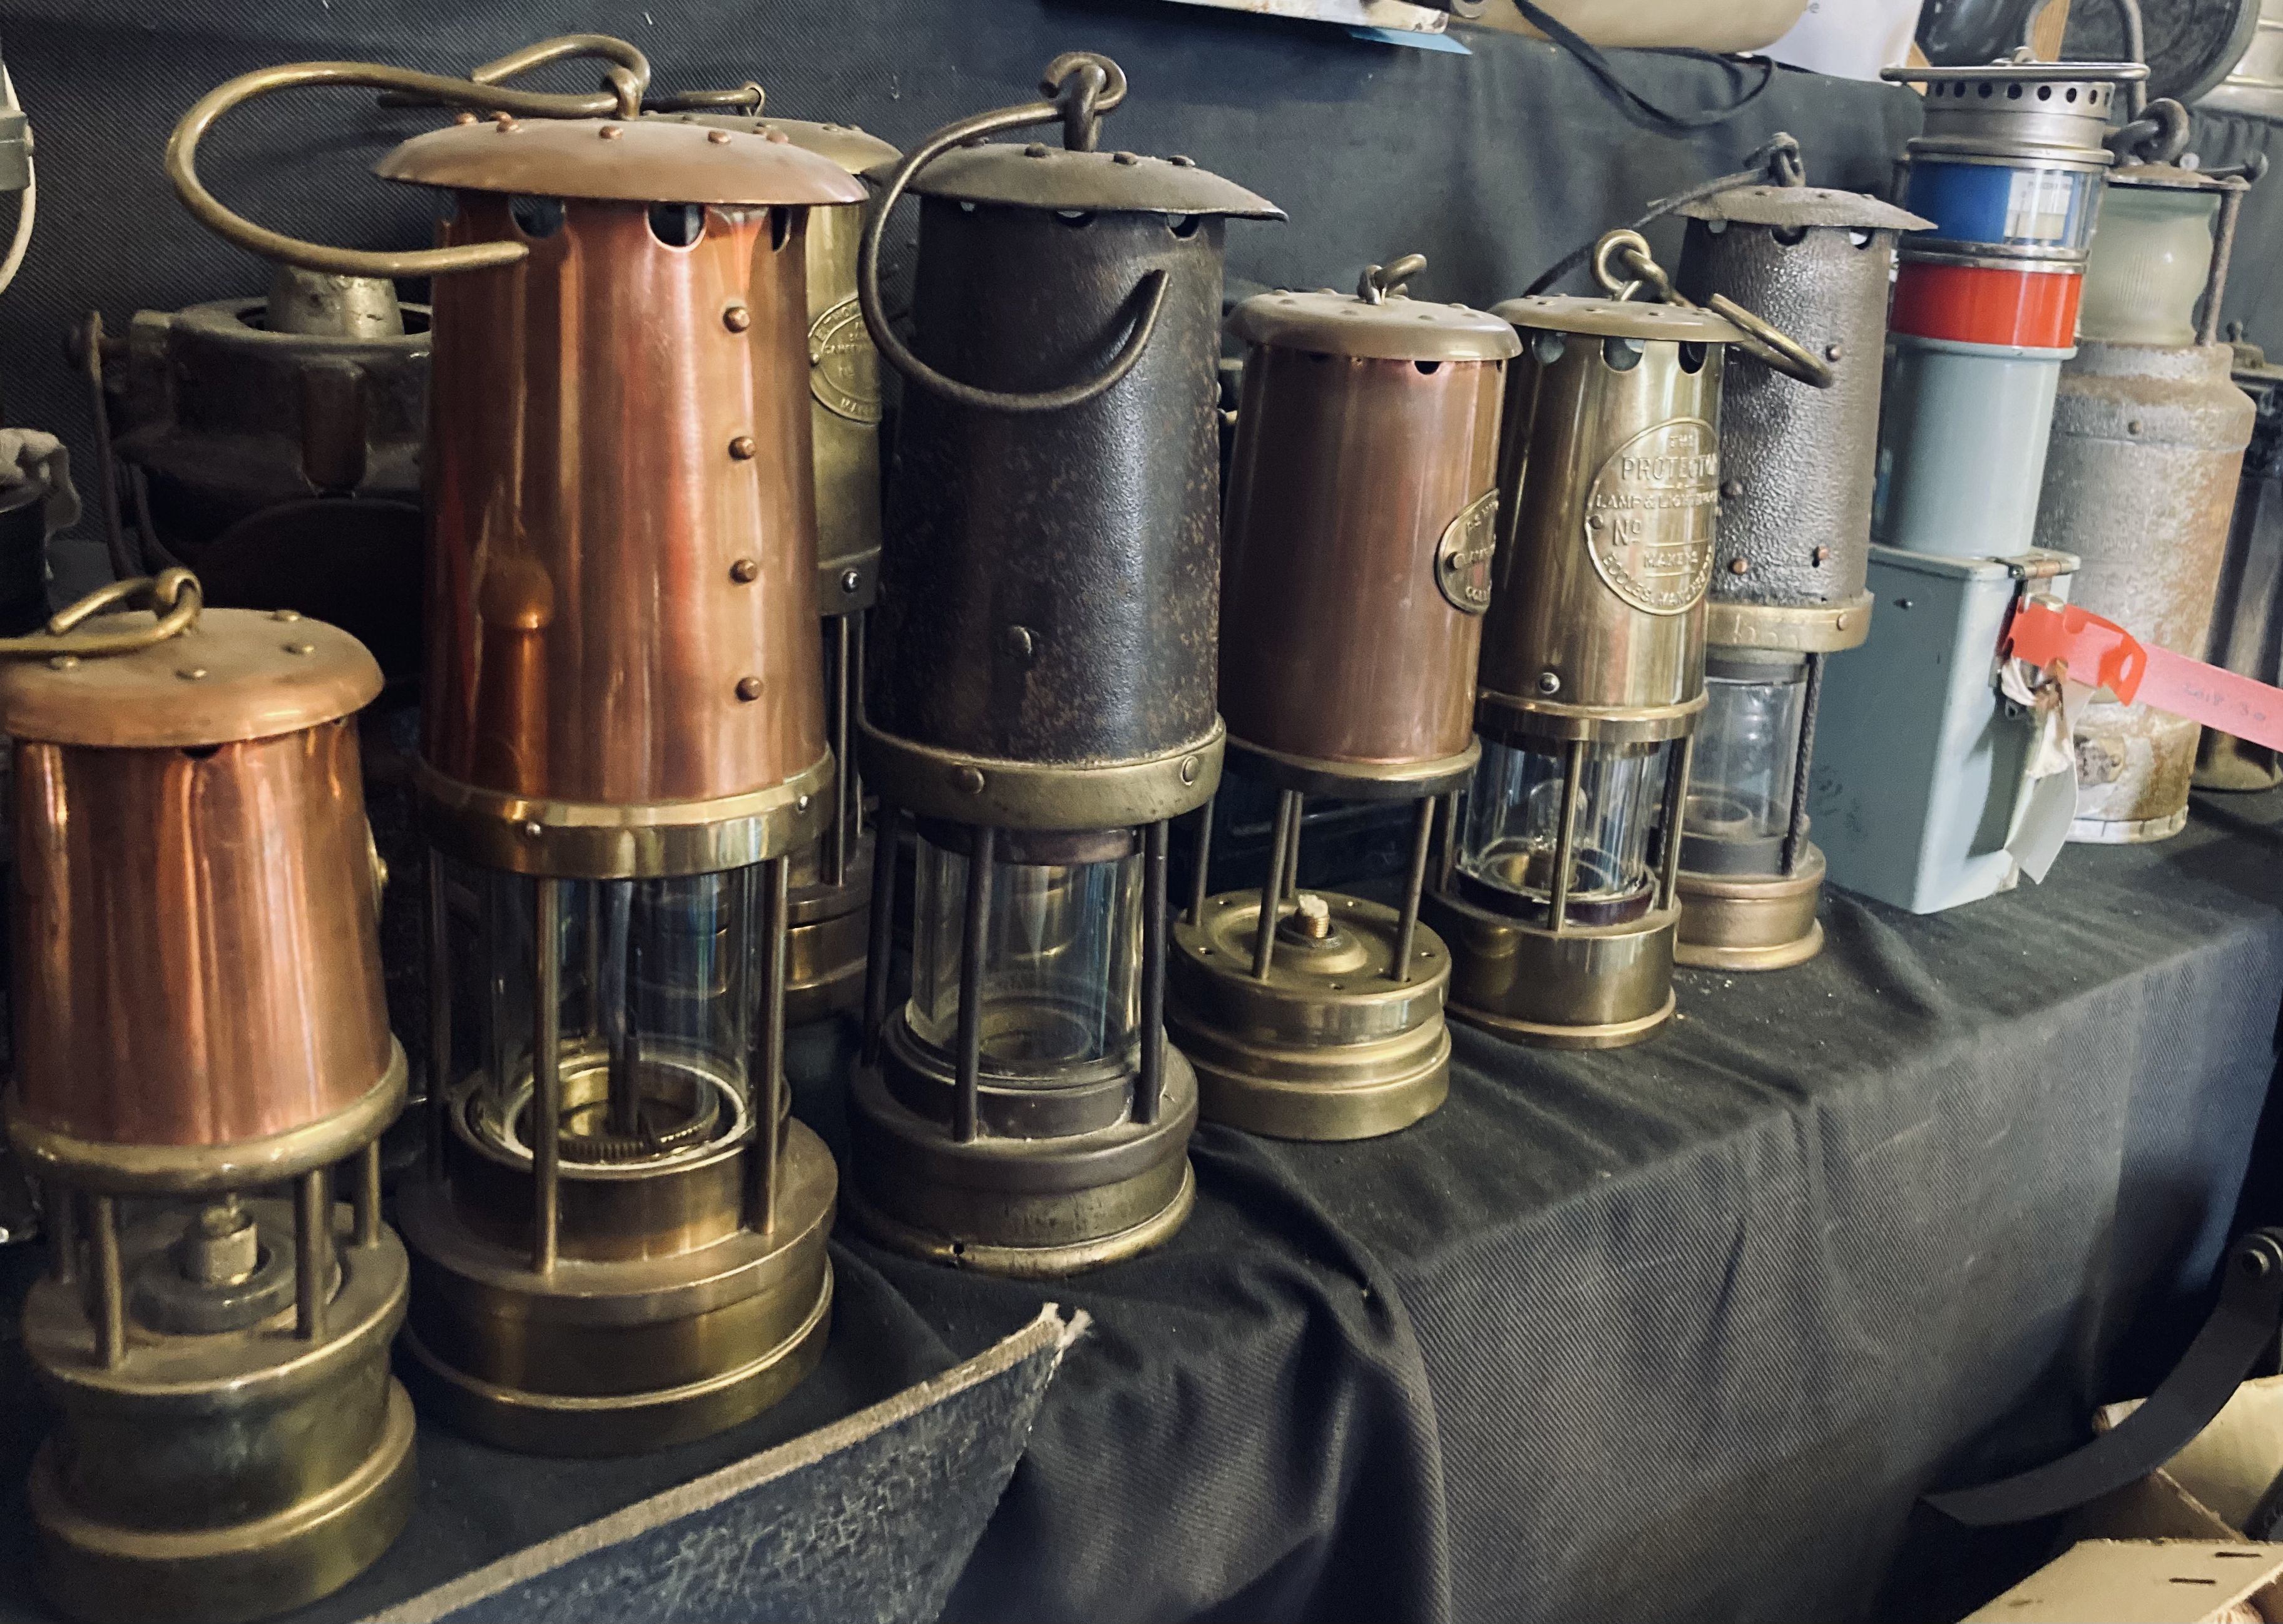  These are the sort of items that we need to catalogue so we know what is in our collection.
Events | What have we been up to?...  There have been several events recently, including a fantastic open day at the large Overseal Parade and Gala, two open days at Snibston Colliery Park (A Coal Miner’s Story Tour), and an open day at Gresley Old Hall.  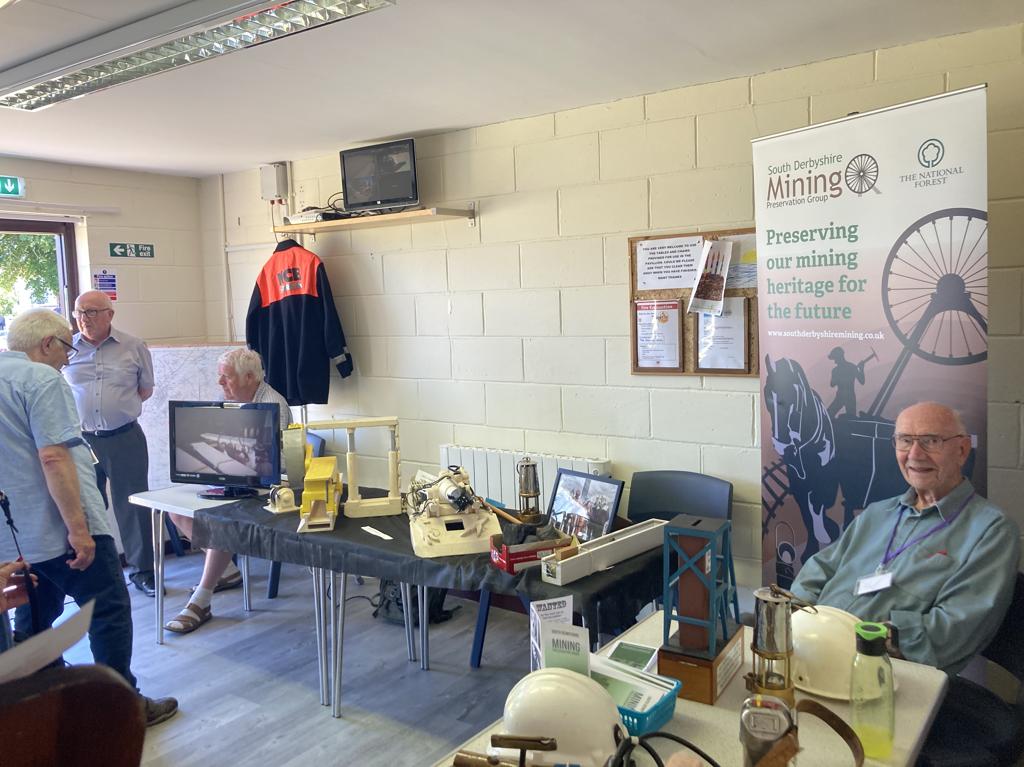  We were also able to support a local school by providing selected mining artefacts for their mining history project. Unfortunately, we cannot attend schools to personally demonstrate such events, but we have a qualified teacher producing resources and lesson plans for local primary schools to use and adapt in the coming months. Please get in touch if you would be interested in this.  What’s coming up?...  For the future we hope to take part in the forthcoming Heritage events in cooperation with the Magic Attic. We will be based in/or in front of the town hall between 10-4pm. Please come and see us!

