- Volume 2｜Issue 3  Autumn 2023 | South Derbyshire Mining Preservation Group Newsletter
Welcome | You don’t need to be an ex-miner to join us – maybe you have an interest in history, helping, or just fancy a chat.  We meet in person at Gresley Old Hall every Tuesday, 10-12pm.  Contact Details  Website: www.sdmpg.webador.co.uk  Twitter: @S_D_M_P_G  Email: southderbys.mpg@gmail.com.  We’d love to hear from you…  We (still) need you!  We have lots of tasks (including cataloguing, educational resourcing, tidying, displaying, organising and creating) that are underway at the Old Hall and Conkers presently. If you think you can offer any help, please pop in and see us – there is something here for every talent.  SDMPG
Events | What have we been up to?...  We are still updating our display at Conkers – it’s just through the shop and is free to enter if you would like to visit. If you think you could lend a hand with this, then please get in touch.  We are also still working our way through cataloguing our large collection of mining items. This is a huge task but essential to understand the extent of our collection.  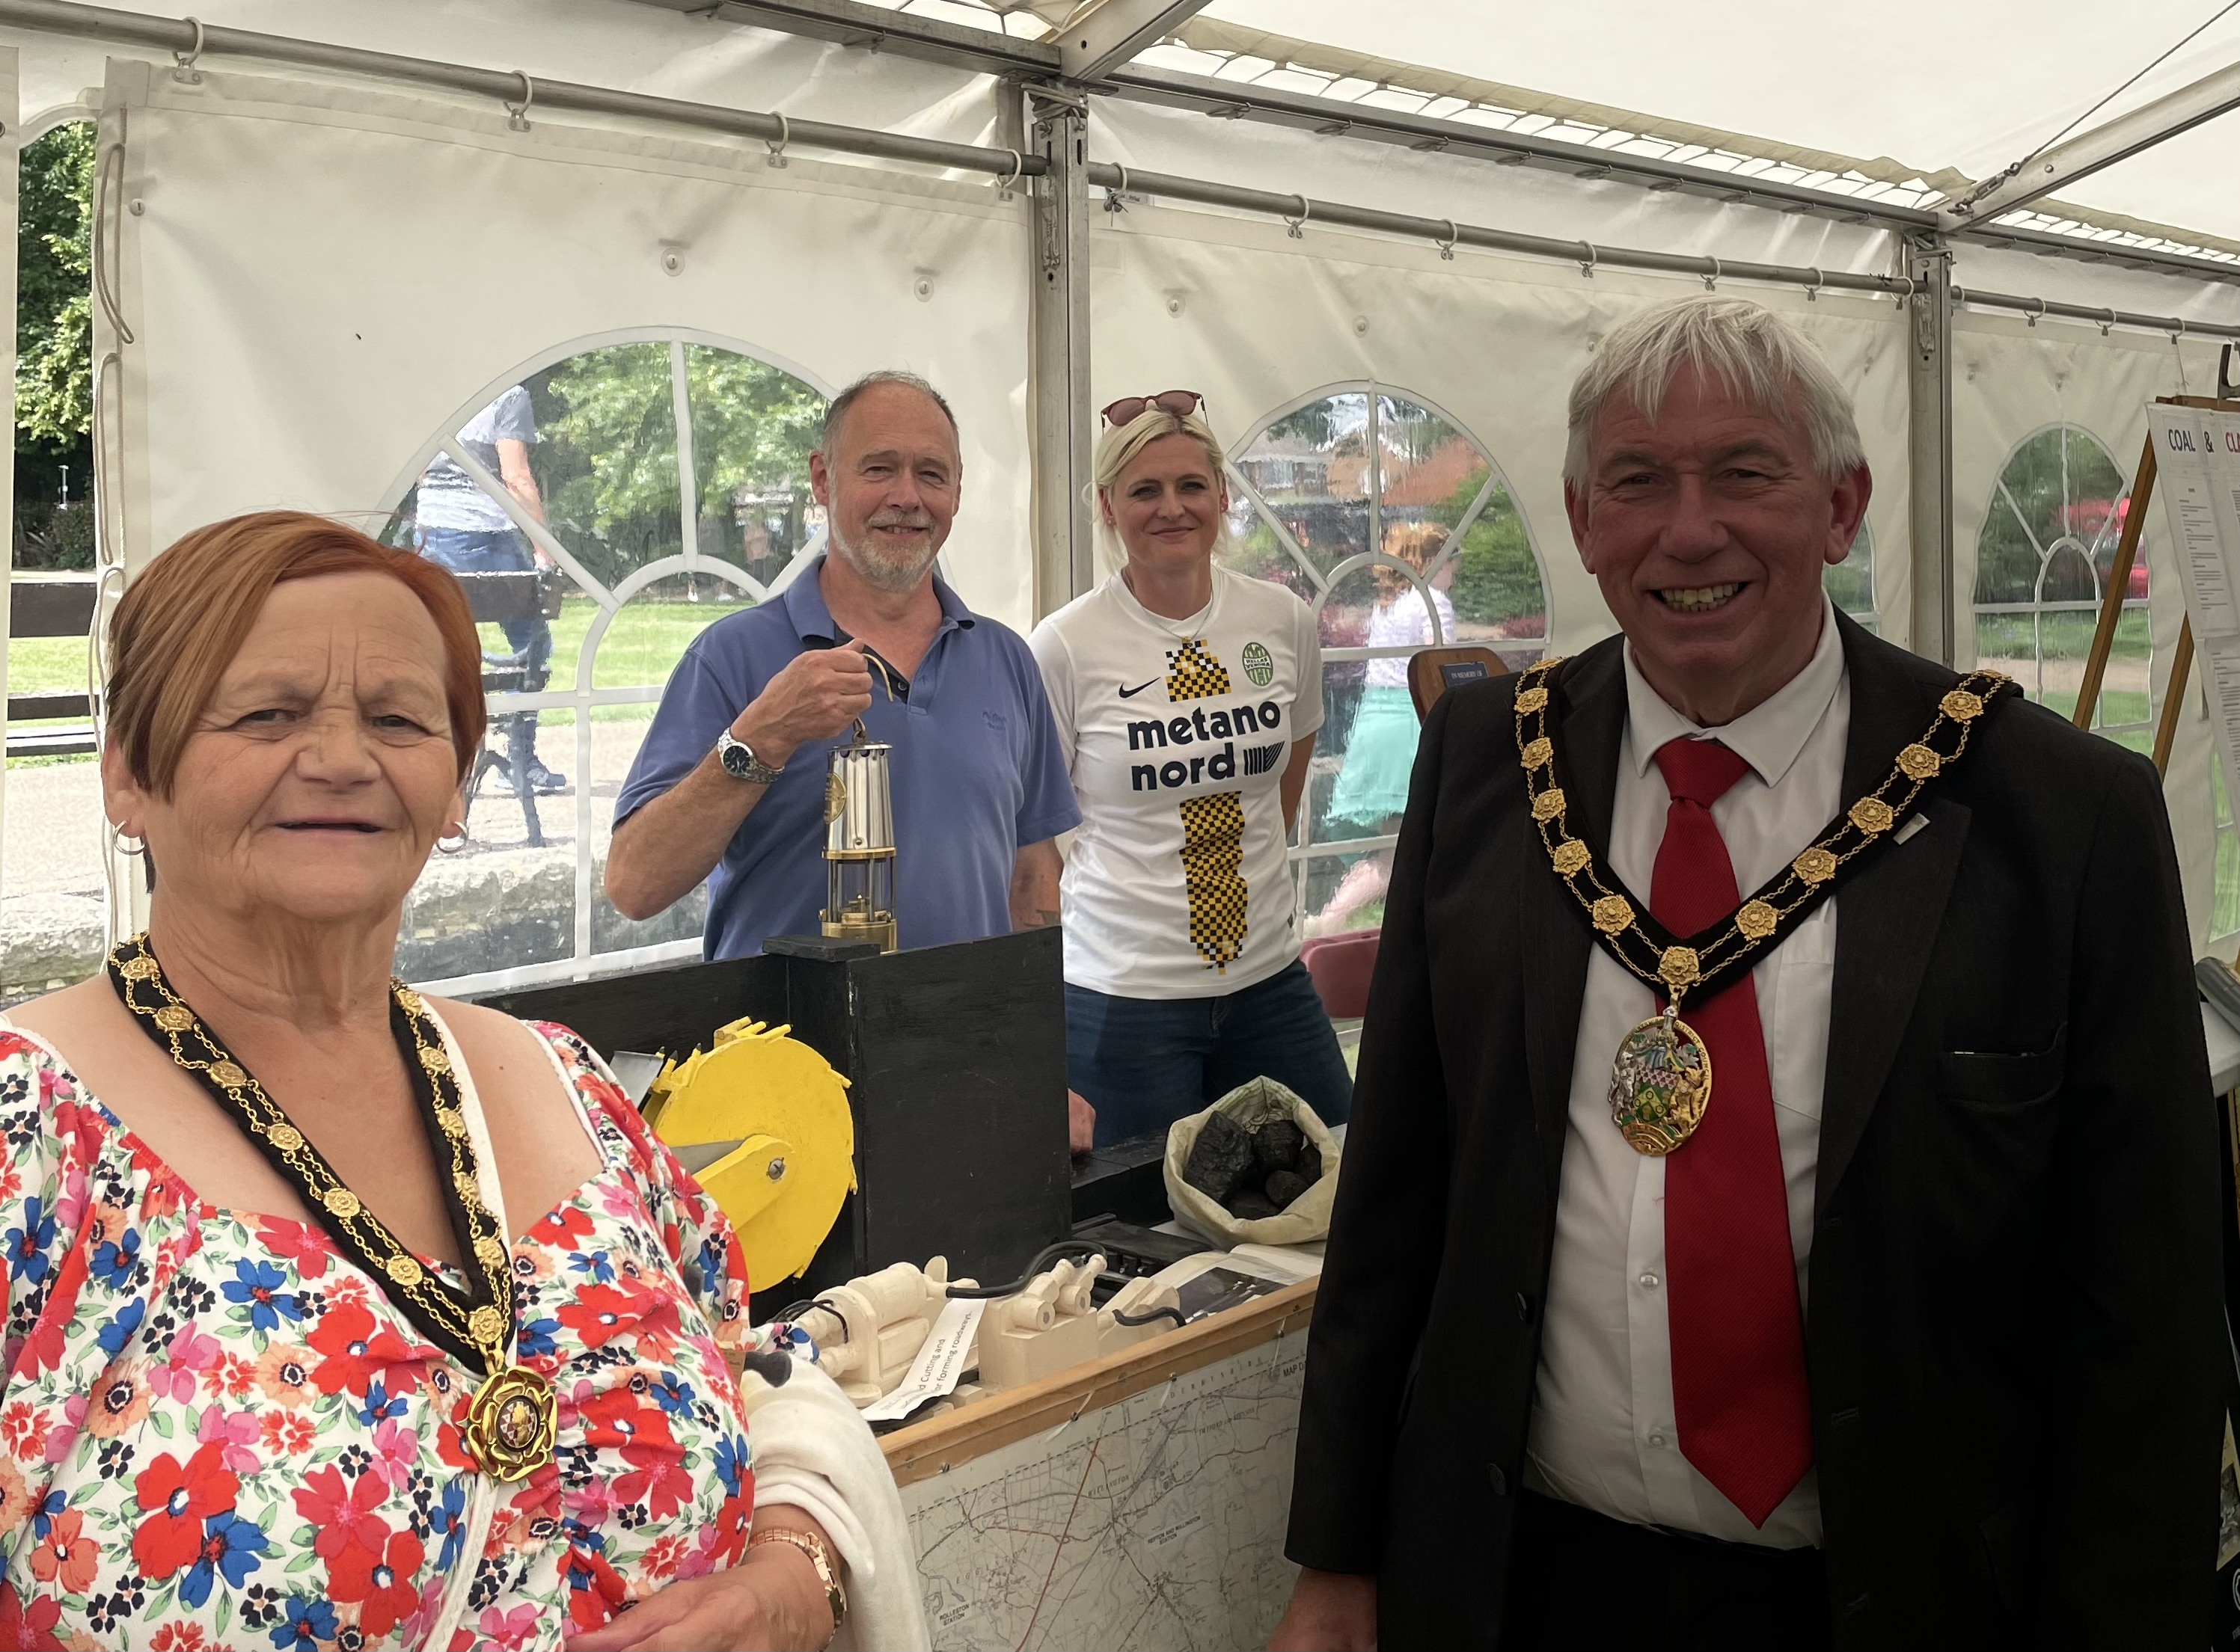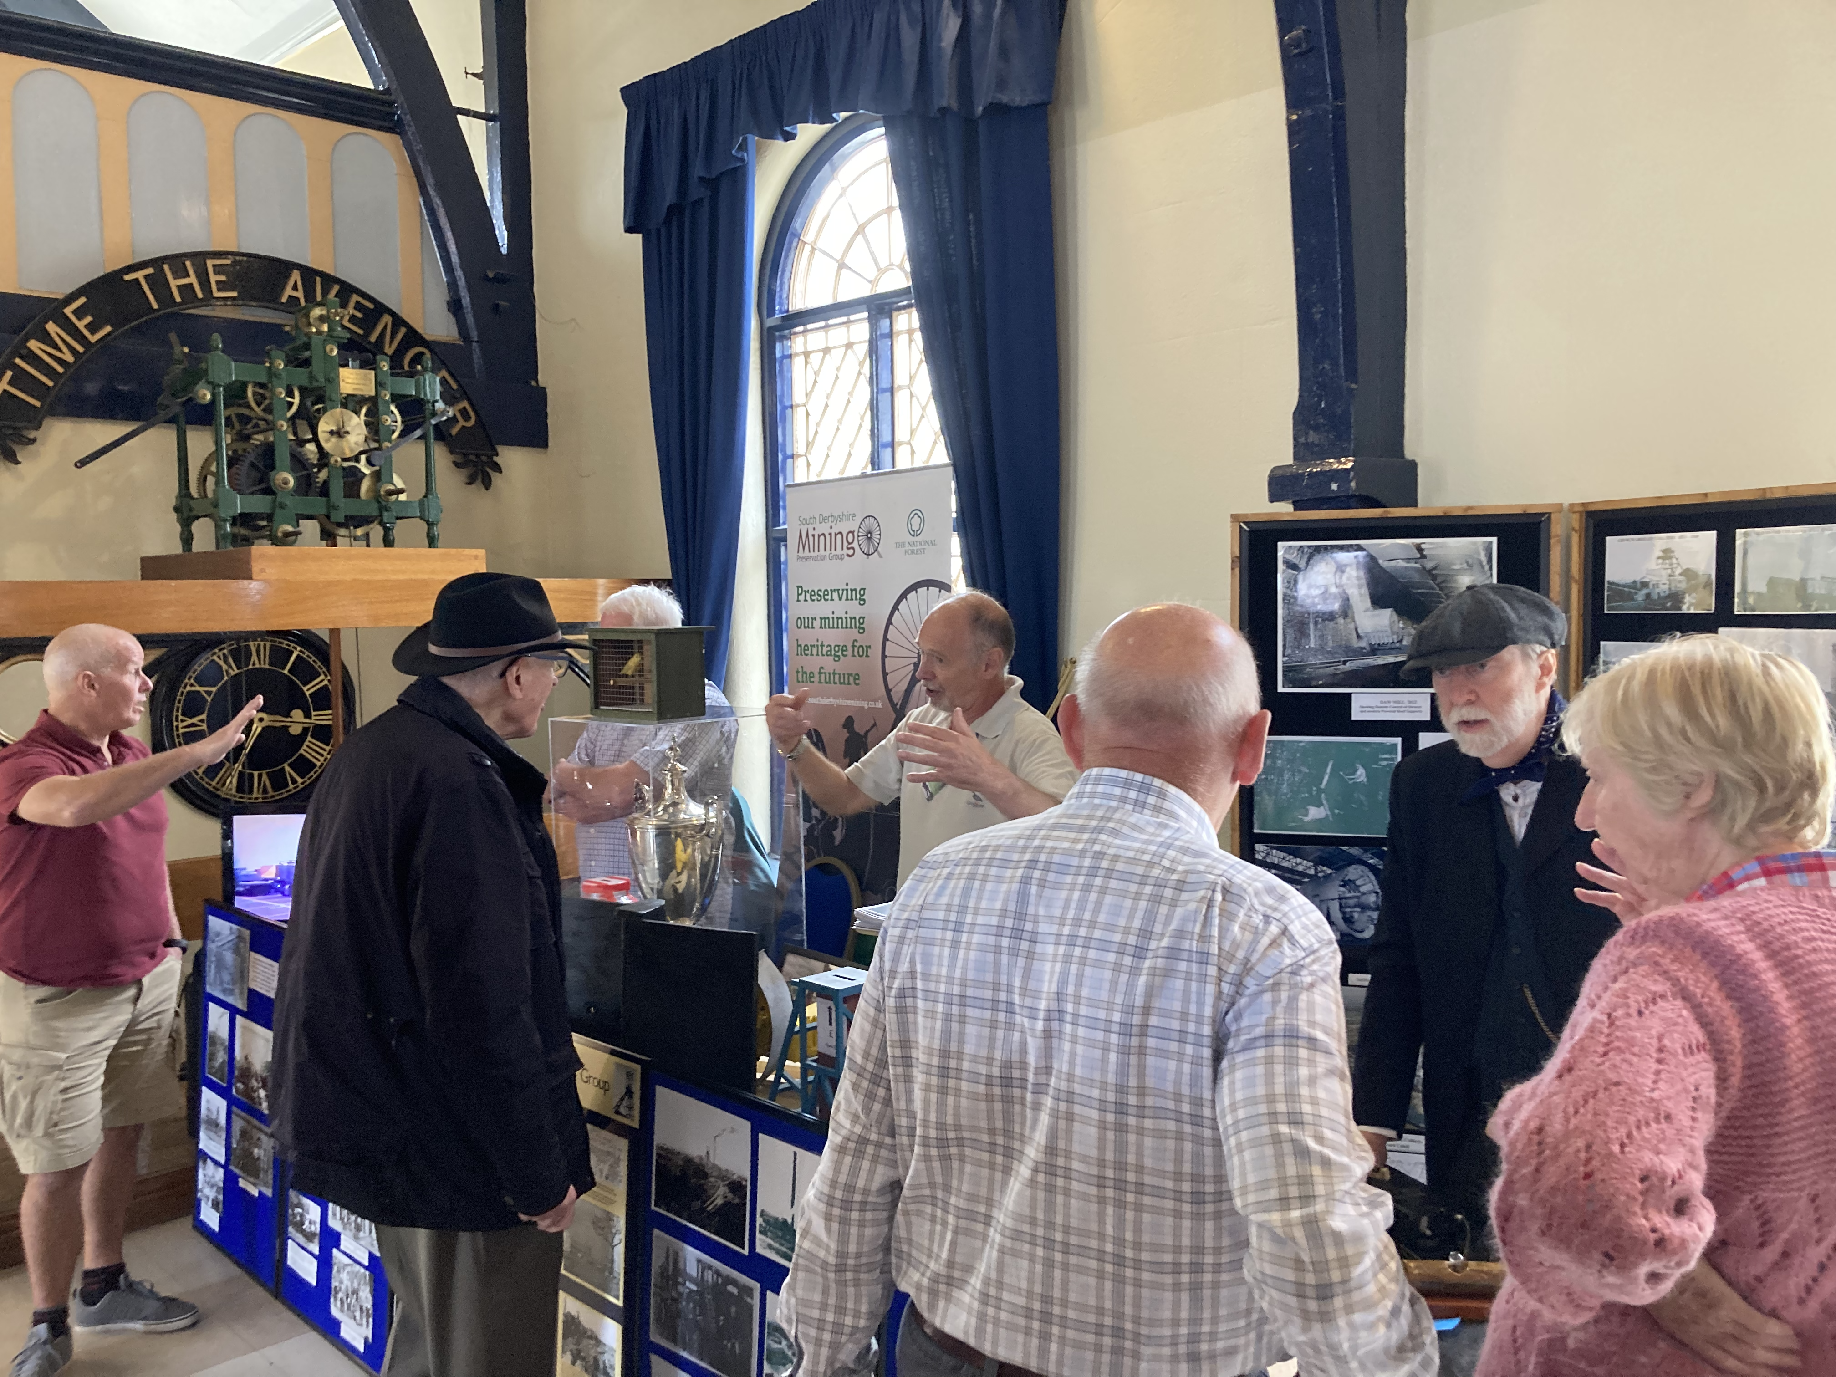  We have been busy attending local events over the last few months, including the fabulous Festival of Leisure in Maurice Lea Memorial Park, Coton Park celebrations and Swadlincote Heritage Open Days. We also had a wonderful display in the Swadlincote Visitor Information Centre throughout June.  What’s coming up?...  Heritage Open Days at Swadlincote Town Hall, 16th and 17th September, 10am-4pm.  Memories Day at St George and St Mary’s Church Community Centre, 21st October

