- Volume 3｜Issue 2  Spring 2024 | South Derbyshire Mining Preservation Group Newsletter
Welcome | Exciting News!  We have moved! We are now meeting every Tuesday, 10am-12pm at our new home – Sharpe’s Pottery in Swadlincote. Here we are alongside other local and heritage groups including Sharpe’s Pottery Museum, The Magic Attic and People Express. Hopefully, the more central location and disabled access will encourage more people to come and visit us. You don’t need to be an ex-miner to join us – maybe you have an interest in history, helping, or just fancy a chat. We will also be having our artefacts on display in the museum – watch this space!    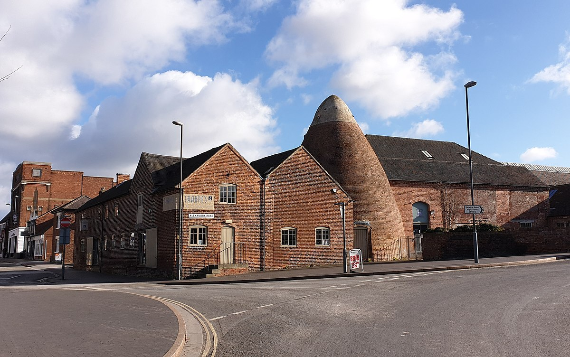  We (still) need you!  Given our exciting news about our move to Sharpe’s, we really need volunteers to help with cataloguing, organising, and other projects we hope to work on soon. We have never been more accessible now we are based in Swadlincote’s Cultural Quarter, and we have disabled access.
Events | What have we been up to?...  Most of our recent efforts have centered around moving our vast, wonderful and eclectic collection to Sharpe’s. We are still updating our display at Conkers – it’s just through the shop and is free to enter, so please go and take a look…  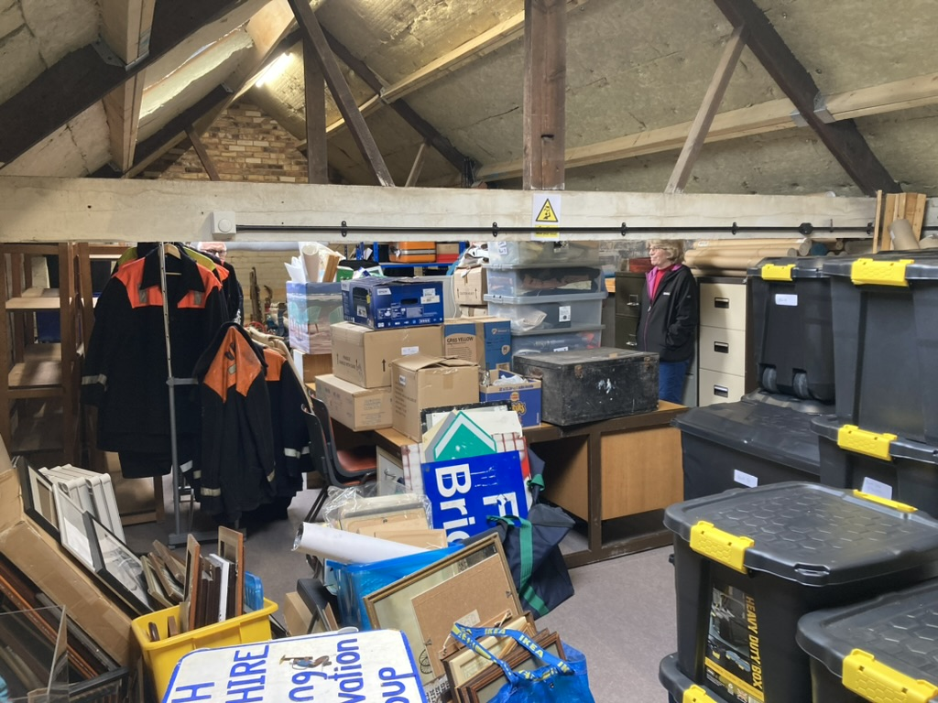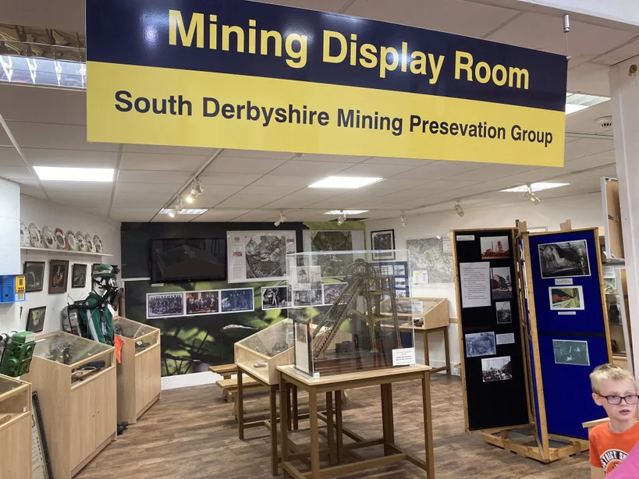  What’s coming up?...  - Festival of Leisure, Maurice Lea Memorial Park – 22nd and 23rd June 2024  - Swadlincote Heritage Open Days, Swadlincote Town Hall – 14th and 15th September 2024  - Exhibition, Swadlincote Visitor Information Centre - October 2024  Contact Details  Website: www.sdmpg.webador.co.uk  Twitter: @S_D_M_P_G  Facebook: facebook.com/61559901483044/  Email: southderbys.mpg@gmail.com.  Telephone: 01283 567494 or 01283 761505

