- Volume 2｜Issue 2  Summer 2023 | South Derbyshire Mining Preservation Group Newsletter
Welcome | You don’t need to be an ex-miner to join us – maybe you have an interest in history, helping, or just fancy a chat.  We meet in person at Gresley Old Hall every Tuesday, 10-12pm.  Contact Details  Website: www.sdmpg.webador.co.uk  Twitter: @S_D_M_P_G  Email: southderbys.mpg@gmail.com.  We’d love to hear from you…  We (still) need you!  We have lots of tasks (including cataloguing, educational resourcing, tidying, displaying, organising and creating) that are underway at the Old Hall and Conkers presently. If you think you can offer any help, please pop in and see us – there is something here for every talent.  SDMPG
Events | What have we been up to?...  We are still updating our display at Conkers – it’s just through the shop and is free to enter if you would like to visit. If you think you could lend a hand with this, then please get in touch.  We are also still working our way through cataloguing our large collection of mining items. This is a huge task but essential to understand the extent of our collection.  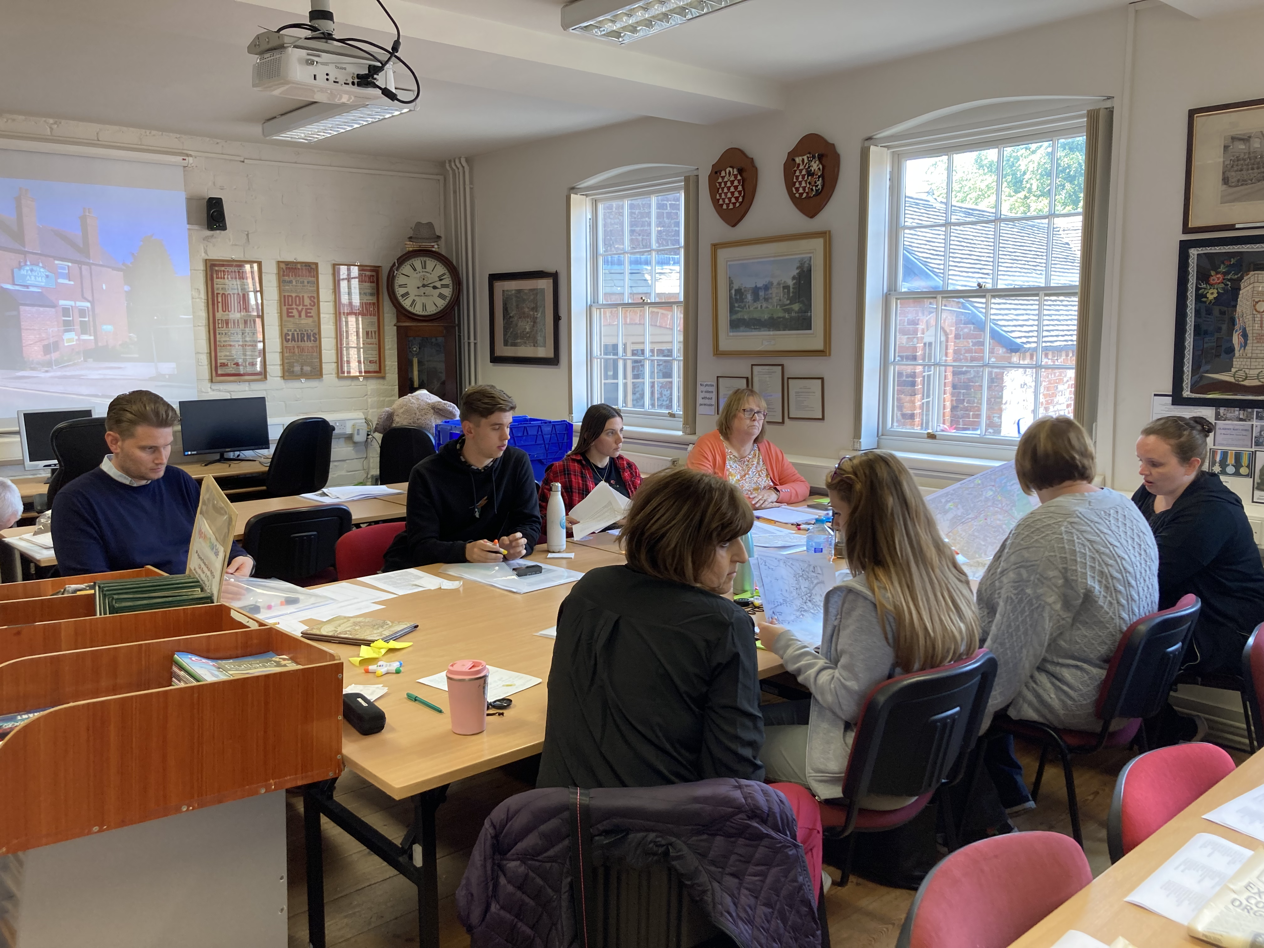  We have been busy creating resources (with the help of Historic England) that local primary schools can use to facilitate the teaching of the region’s local coal mining history. On 7th June we delivered a training session to local teachers in how to use the new resources. These will soon be uploaded to the website and physical resources are also available. Just get in touch if you think we can help.  What’s coming up?...  Throughout June - Display in Swadlincote Visitor Centre  Saturday 17th June - Open Day, Gresley Old Hall, 10-2pm  Saturday 24th & Sunday 25th June - Festival of Leisure, Maurice Lea Memorial Park, 11.30-5pm

